Support link: <https://www.jenkins.io/doc/book/pipeline/syntax/>

Declarative Pipeline

Declarative vs scripted pipeline- It’s just a different way of writing pipeline.

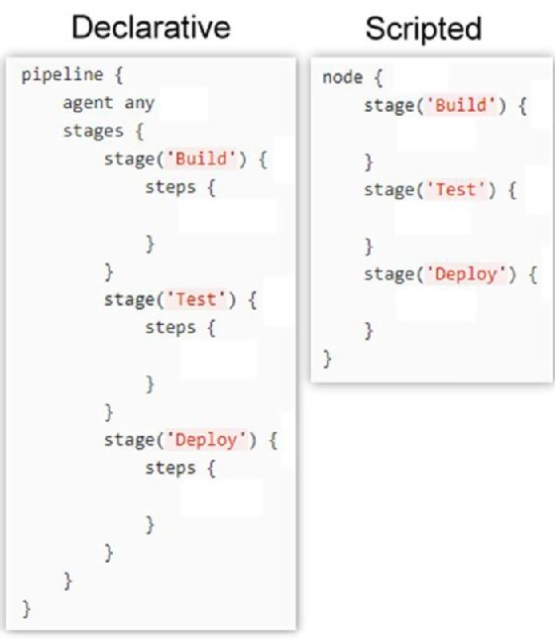

Limitations: There is currently an [open issue](https://issues.jenkins.io/browse/JENKINS-37984) which limits the maximum size of the code within the pipeline {} block. This limitation does not apply to Scripted Pipelines.

Sections

* agent
* post
* stages
* steps

Directives

* environment

|  |  |
| --- | --- |
|  | * An environment directive used in the top-level pipeline block will apply to all steps within the Pipeline. |
|  | * An environment directive defined within a stage will only apply the given environment variables to steps within the stage. |
|  | * The environment block has a helper method credentials() defined which can be used to access pre-defined Credentials by their identifier in the Jenkins environment. |

* options
* parameters
* triggers
* Jenkins cron syntax
* stage
* tools
* input
* when

Sequential Stages

Parallel

Matrix

* axes
* stages
* excludes (optional)
* Matrix cell-level directives (optional)

Steps > script

Scripted Pipeline

* Flow Control
* Steps
* Differences from plain Groovy

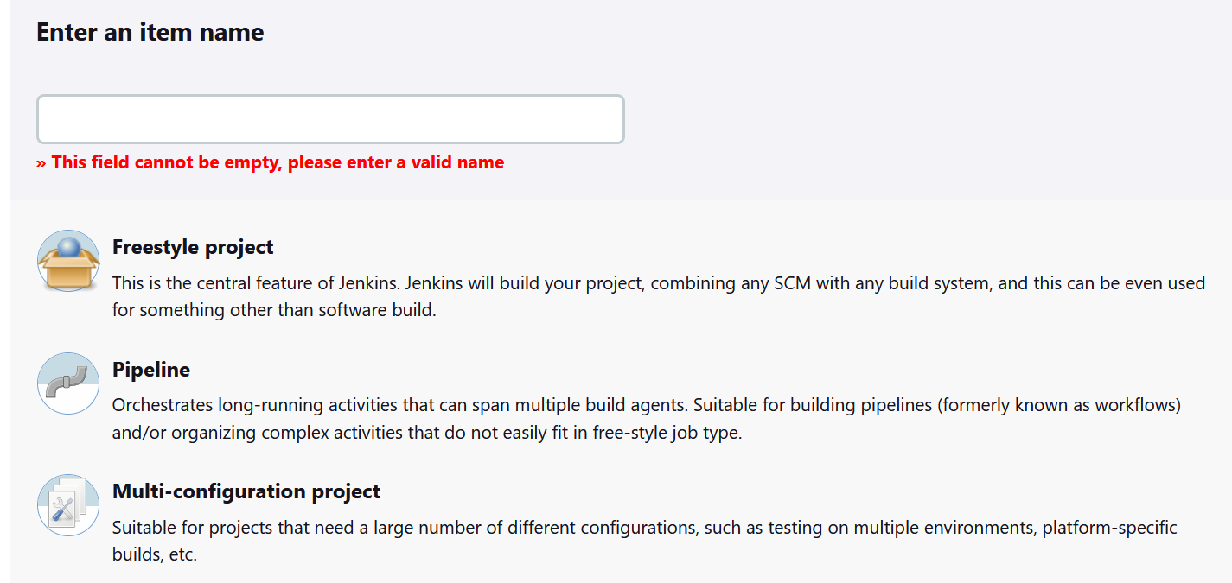

Discard old builds

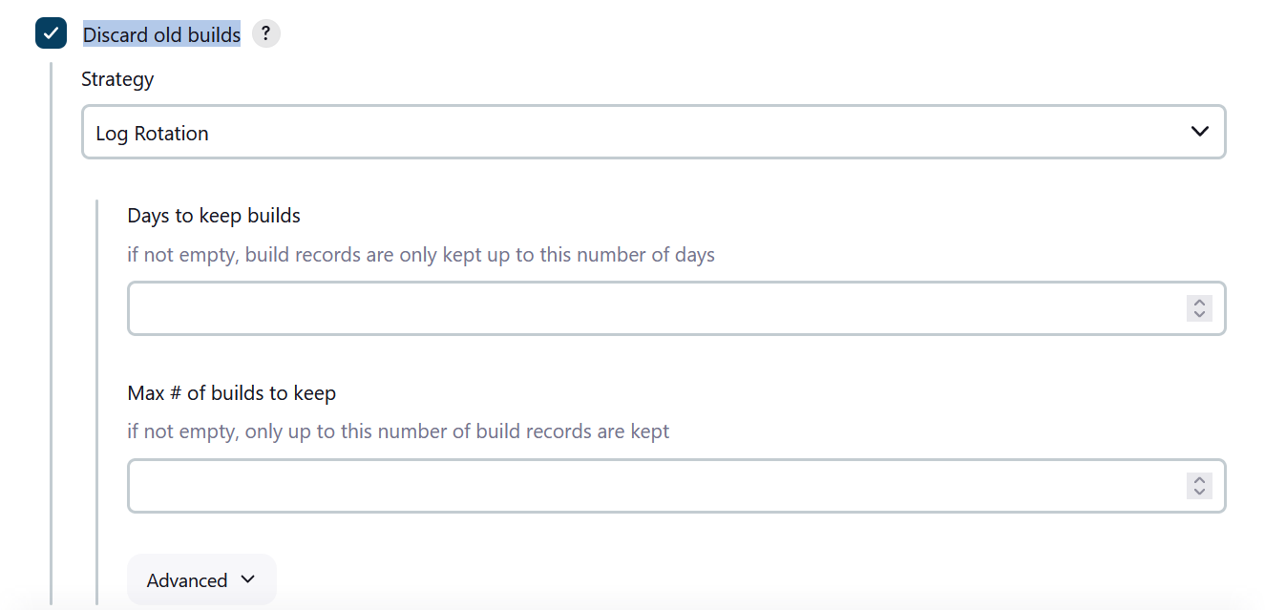

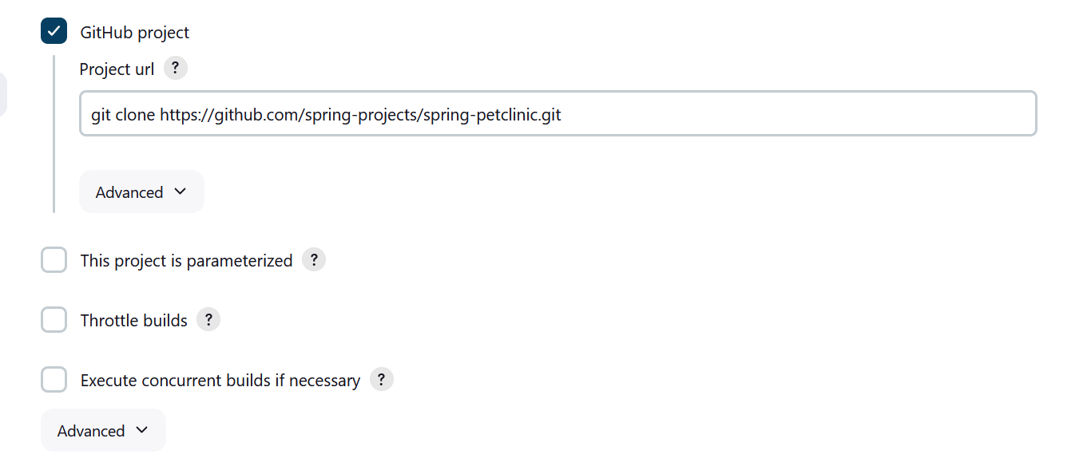

Throttle build

This plugin **allows for throttling the number of concurrent builds of a project running per node or globally**.

